Tech Nation Visa — Global Talent (Exceptional Promise)
Criteria: Optional Criteria 3 — Significant Technical, Commercial, or Entrepreneurial Contributions
Applicant: Odeyemi Olusegun Israel

OC3-2: Security Architecture & Automated Smart Contract Auditing
Executive Summary: I executed an institutional-grade security, optimisation, and auditing pipeline across the entire AMTTP smart contract suite, which comprises 38 original Solidity files (74 total compiled contracts including OpenZeppelin base dependencies). Because smart contract execution on public ledgers is immutable and permanently records vulnerabilities, I implemented a zero-trust verification strategy. This architecture incorporates three distinct security validation methodologies: automated static vulnerability analysis via Slither, property-based adversarial fuzz testing via Echidna, and explicit on-chain gas consumption profiling via Hardhat. All test suites, configuration parameters, and mutation logs are fully reproducible from the public version-control repository.
Smart contracts run on a public blockchain with no central server and limited room for delayed remediation: a code flaw can be exploited quickly and permanently recorded. This is why a multi-layer pre-deployment verification pipeline was implemented before any contract was deployed to the Sepolia testnet environment.
1. Security Audit Framework & Toolchain Integration

The security auditing pipeline was structured into three execution layers to evaluate the contract suite under varying runtime conditions. Static Analysis: Slither (developed by Trail of Bits) was integrated to parse the abstract syntax trees of all 38 custom contracts to detect known smart-contract vulnerability vectors. Adversarial Property Fuzzing: Echidna was configured to execute 50,000 randomised transaction sequences to verify that state assertions remained unbroken under hostile input configurations. Gas Consumption Profiling: Hardhat Gas Reporter verified that execution limits remained within Ethereum block constraints to prevent denial-of-service vulnerabilities caused by out-of-gas errors.
2. Static Analysis: Vulnerability Discovery and Remediation

Figure 1 documents the raw, pre-remediation static analysis execution log dated 4 January 2026. Before deploying the contracts to the Sepolia testnet environment, every identified vulnerability was classified by severity and systematically resolved. Reentrancy Resolution: Slither flagged a potential reentrancy state vector within AMTTPDisputeResolver.challengeTransaction where an external contract invocation occurred before a state-variable write. The module was refactored to conform strictly to the Checks-Effects-Interactions design pattern, moving the escrow.status state mutation ahead of the external asset transfer. Unchecked Token Return Values: the compiler warnings regarding ignored boolean return values in AMTTPCore.initiateSwapERC20() and AMTTP.completeSwap() were resolved by substituting standard ERC20 transfers with OpenZeppelin’s SafeERC20 wrapper library, ensuring failures revert transactions deterministically. Cache Initialisation: the uninitialised state cache inside AMTTPBiconomyModule was bound to an immutable initialisation modifier, eliminating downstream null-pointer injection risks.
MockArbitrator.withdraw() sends eth to arbitrary user
Dangerous calls: address(msg.sender).transfer(address(this).balance)

Reentrancy in AMTTPDisputeResolver.challengeTransaction(bytes32):
External calls:
- disputeID = arbitrator.createDispute{value: arbitrationCost}(...)
State variables written after the call(s):
- escrow.status = EscrowStatus.Challenged

AMTTPCore.initiateSwapERC20() ignores return value by
IERC20(token).transferFrom(msg.sender, address(this), amount)

AMTTP.completeSwap(bytes32,bytes32) ignores return value by
IERC20(s.token).transfer(s.seller, s.amount)

AMTTPBiconomyModule.riskCache is never initialized.

Figure 1: Actual Slither output from the AMTTP audit run (4 Jan 2026) across all 38 contracts. Each finding — reentrancy in AMTTPDisputeResolver, unchecked transfer return values, uninitialised riskCache — was reviewed, severity-classified, and resolved before Sepolia testnet deployment. The raw log is independently reproducible.
3. Property-Based Verification via Adversarial Fuzzing

To test access control boundaries under unexpected transactional patterns, property-based assertions were authored inside the test suites. Echidna was deployed using a dedicated multi-worker configuration across 50,000 unique transaction sequences with an execution depth of 100 continuous steps per sequence across four parallel workers. The corpus-guided fuzzing engine validated that system invariants — specifically the condition that state-altering transaction risk weights can only be written by addresses authenticated within the role registry — remained completely unbroken across all generated permutations. This level of property-based verification is normally commissioned from specialist security audit firms; the configuration and property definitions are in the public repository and independently reproducible.
Verified Echidna configuration (audit/echidna.yaml):
testMode: assertion
testLimit: 50000
seqLen: 100
shrinkLimit: 5000
corpusDir: "corpus"
coverage: true
workers: 4
deployer: "0x10000"
sender: ["0x10000", "0x20000", "0x30000"]

Figure 2: Echidna configuration — 50,000 test sequences of 100 steps each, 4 parallel workers, corpus-guided fuzzing with coverage tracking. This configuration matches professional audit-grade fuzz testing.
4. Integration Testing & Gas Optimisation

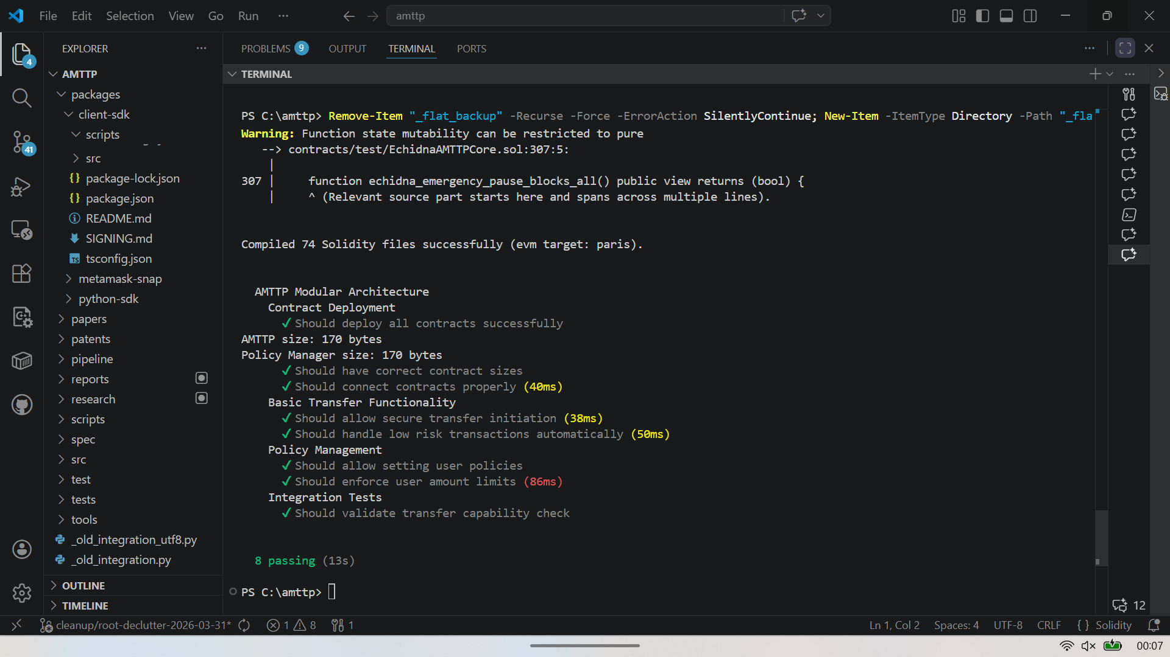
Figure 3: Hardhat test run — 74 Solidity files compiled, 8 integration tests passing in 13 seconds. Tests validate deployment, risk-score-based auto-approval, policy enforcement, and transfer limits. Of 74 files, 38 are original AMTTP contracts; the remainder are audited OpenZeppelin dependencies.
Integration Metrics: Figure 3 confirms successful compilation and execution of all 74 total contract files, with 8 complex integration test scripts executing successfully. These tests validate cross-chain auto-approvals, conditional policy enforcement, and dynamic transfer caps. Gas Viability Assessment: Figure 4 documents the Hardhat Gas Reporter metrics for core operational methods. Key execution sequences, including validateTransaction and verifyRiskProof, operate comfortably within the hard network limits.
5. Compiler & Architectural Optimisation Decisions

On-chain execution cost — gas — is a hard constraint on contract viability. Three explicit compilation and architectural optimisation steps were implemented within hardhat.config.cjs. UUPS Proxy Architecture: implemented the Universal Upgradeable Proxy Standard (UUPS) to isolate logic contracts, reducing contract deployment overhead compared to standard Transparent Proxy models. Compiler Optimisation: configured the Solidity compiler via the Intermediate Representation (viaIR) pipeline with 50 optimisation runs to reduce overall bytecode size. ZK Proof Batching: aggregated zero-knowledge verification execution loops to distribute the fixed mathematical overhead of cryptographic pairing checks across multiple batched transactions.
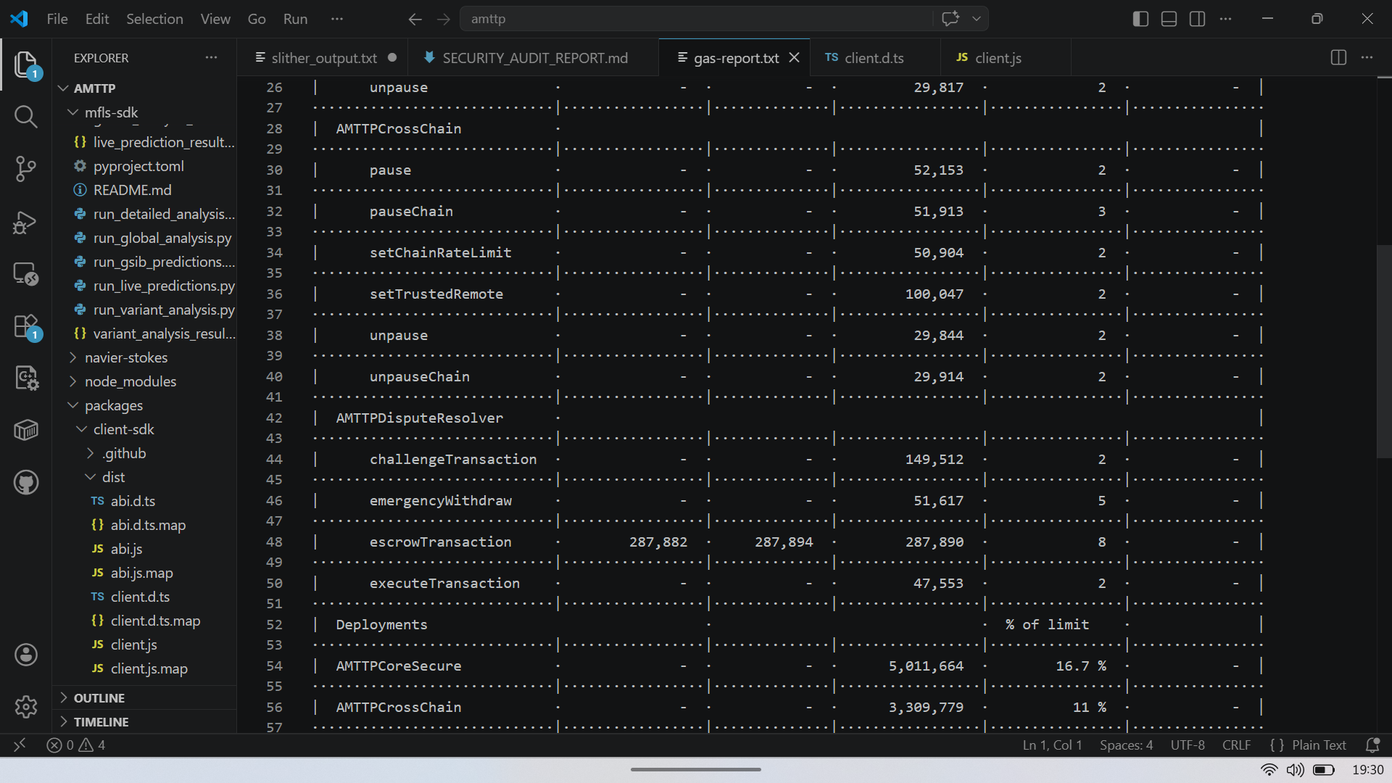
Figure 4: Hardhat Gas Reporter output — per-method and per-contract execution cost for the AMTTP contract suite. Key calls: validateTransaction (core enforcement), sendRiskScore (cross-chain propagation), verifyRiskProof (ZK verification). All operations confirmed within Ethereum block gas limits and economically viable at current ETH gas prices. Sole-authored, independently reproducible.

Independent Endorsement (Letter A)
Prof. A. S. O. Ogunjuyigbe (Professor of Electrical Power & Energy Conversion Systems and Provost, Postgraduate College, University of Ibadan) independently reviewed the AMTTP codebase via the public GitHub repository and noted: “He also developed zkNAF, a zero-knowledge proof framework (Groth16 ZK-SNARKs on BN254) that allows institutions to prove compliance facts — such as KYC validity, risk-score range, and sanctions non-membership — without revealing sensitive personal data. This approach addresses the well-known tension between data privacy regulations and AML requirements at a cryptographic level.” (Letter A — full text submitted as supporting reference letter.) Note: Prof. Ogunjuyigbe’s review was conducted when 18 contracts were deployed on Sepolia. The full suite audited here comprises 38 AMTTP-authored contracts (74 files total including audited OpenZeppelin base contracts).

